The Autumn Pack - Product Application Guide
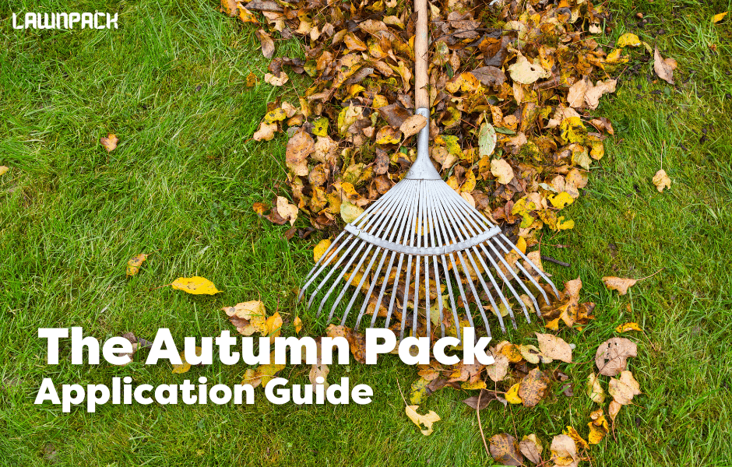
Give your lawn a boost while preparing it for the colder months. Autumn Preparation Fertiliser has fast and slow release nitrogen to maintain green colour throughout the whole season.
This Autumn pack will encourage the lawn to thicken up and deepen roots without causing too much excess growth. Lawn diseases are very common in autumn due to the warm and wet conditions which is why our fertiliser has high levels of potassium to increase resistance. As with all our seasonal packs we have also included a Biostimulant Booster which increases the mass of the root network, improves soil microbiology, grass blade density and nutrient absorption. Best applied from September to November.
Autumn Preparation Fertiliser
Apply the seasonal fertilisers evenly across the lawn at 25-35g per SQM ideally with a spreader. You can apply up to 40g per SQM if you have red thread disease.
Biostimulant Booster
Follow up with 4-5ml of Biostimulant Booster diluted in 250ml of water per SQM evenly applied with a watering can with a fine rose head or a pressure sprayer. You can dilute using more water if needed.
Maintenance
Maintaining your lawn throughout the year is about using the correct products along with carrying out the correct practices.
- Mowing: Every 4-7 days while the grass is still growing fast then reduce to every 7-14 days as we get closer to the end of autumn as growth slows
- Leaves: Make sure to remove any leaves as soon as possible from your lawn as they will stifle the grass growth underneath and cause it to yellow or even die if left long enough.
- Weed control: You can only use selective herbicides on weeds up to around the end of September while they are still actively growing.
- Overseeding: Autumn is a period where many choose to do renovation work on their lawn due to the good conditions. We have seed available individually on the website but ideally
Wait at least 8 weeks after applying The Lawn Pack renovation kit or the Spring Pack before applying The Autumn Pack.
What's Up Next?
Apply The Winter Pack to protect your lawn over winter - usually the harshest season of the year for grass. Applied December - February.
Winter Protection Fertiliser promotes deep rooting for a more resilient turf. Deeper Green Iron Sulphate can be used to treat moss and will green up your lawn while hardening the turf to make it more resistant. Also contains Biostimulant Booster.

